Comparing 3D Matrix Rich Zones in Ceramic Matrix Composites Using Orthogonal Decomposition
I. Emami-Tabrizi¹, W.J.R. Christian^{1a}, C. Przybyla², and E.A. Patterson¹
¹School of Engineering, University of Liverpool, Liverpool, UK,
²Air Force Research Laboratory, Wright-Patterson AFB, OH, USA
ªw.j.r.christian@liverpool.ac.uk

Abstract. This study has developed a technique to extract and compare microstructural features present in ceramic matrix composite (CMC) materials using an orthogonal decomposition technique. Raw data was obtained from optical serial sectioning microscopy of a woven SiC_{f}/SiNC laminate and was then segmented using image processing techniques to extract individual matrix rich zones in the 3D microstructure. These microstructural features were described by a large number of voxels making it difficult to compare different features. Therefore, the obtained microstructural features were decomposed using discrete Chebyshev polynomials which enabled each feature to be represented by a comparatively small number of values contained in a feature vector. The results showed that feature vectors helped to extract the main characteristics of the shape of the microstructural features and simplified the process of making comparisons between them.
Introduction
Fibre reinforced ceramic matrix composites address the common drawbacks of conventional ceramic materials such as low thermal shock resistance and low fracture toughness. Therefore, these composites are considered as an excellent candidate for new high temperature aerospace engines and hypersonic vehicles. The lifespan of a CMC part is affected by the distribution and quantity of microscopic defects and inhomogeneities, such as pores, voids, shrinkage cracks, and matrix rich zones (MRZs), which occur during component manufacturing and processing [1].
Characterising these microstructural features can help to improve the micro- and meso- scale modelling of CMC materials. Experimental techniques, such as micro computed tomography and serial sectioning microscopy provide valuable information about the microstructural features of CMC laminates. However, the large size of the datasets generated by these experimental techniques causes challenges when characterising the microstructure.
2D orthogonal decomposition has previously been used to reduce the dimensionality of serial section data characterising the morphology of voids in CMC laminates [3]. In this study, MRZs in a SiC_{f}/SiNC laminate have been extracted using image processing and 3D orthogonal decomposition has been used, enabling comparisons between different MRZs.
Experimental Method
A total of 100 microscope images at 1 µm depth increments were obtained using automated serial sectioning from a 3.6 × 2.6 × 0.1 mm volume of a SiC_{f}/SiNC specimen [3]. The specimens consisted of six layers of plain weave fibres. The obtained micrographs were processed by greyscale thresholding to segment the images into fibre, matrix and voids. There were no clear boundaries between areas with high amounts of matrix and material with a good balance between fibres and matrix. To identify the MRZs, the matrix part of the micrographs was further processed by morphological operations to eliminate the thin portions of matrix that interleave between the fibres resulting in binary images showing the large continuous areas of matrix at each section through the laminate. These binary images were then stacked, resulting in 3D binary volumes showing the separate MRZs in the laminate. The separate MRZs were sorted based on their volume and each of them were decomposed by projecting them onto 3D orthogonal Chebyshev polynomials. This resulted in a reduction in the data from millions of voxels representing each individual MRZ to a few hundred coefficients. Finally, the coefficients were grouped based on the order of the polynomials they corresponded to. The Euclidean norm of each group of coefficients was calculated converting them to a single value. These values were collated into feature vectors that described each microstructural feature in a translation, scale, and rotationally invariant way.
Results and Discussion
The segmentation algorithm was able to identify the matrix rich zones (MRZs) in the laminate, with examples of the largest and fourth largest MRZ presented in Fig.1. The results showed that the MRZs typically possessed very complex morphologies which consisted of columns and chunks of matrix interconnected with each other. The MRZs at interlaminar locations in the laminate (such as Fig.1 top) were found to be more complex than MRZs at the locations where fibre tows crossed over each other in the weave (Fig.1 bottom).
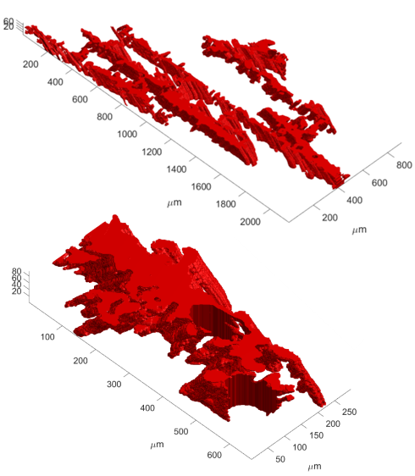
Fig. 1. The largest (top) and fourth largest (bottom) matrix rich zones in the laminate.
In order to categorise the MRZs, the distances between the feature vectors for each MRZ were calculated. These distances were then plotted as a heat map showing pairwise comparisons between the morphology of the five largest MRZs in the microstructure, shown in Fig. 2. The darker colours indicate that the morphologies of the first, second and fifth largest MRZs are more similar to each other than the third and fourth largest MRZs. These three MRZs were at interlaminar location, whilst the other two were at cross-over locations indicating the ability of the technique to categorise MRZs based purely on their morphology.
Fig. 2. Heat map of pairwise similarity between the morphologies of the five largest matrix rich zones, the darker colours indicate higher similarities.
Conclusion
Using image processing techniques, the matrix rich zones in the microstructure of a SiC_{f}/SiNC laminate were extracted and decomposed into feature vectors. The distance between these feature vectors allowed the matrix rich zone morphologies to be quantified, allowing their type to be identified.
References
[1] X. Wang, X. Gao, Z. Zhang, L. Cheng, H. Ma and W. Yang: J Eur Ceram Soc, Vol. 41, No. 9 (2021), p. 4671-4688
[2] C. Sebastian, E.A. Patterson, and D. Ostberg: Appl Mech Mater, Vol. 70 (2011), p. 63-68

