One-shot characterization of material rate-sensitivity from HS images
R. Seghir^{1a}, A. Vinel¹ ², J. Réthoré¹, J. Berthe² and G. Portemont²
¹GeM, Centrale Nantes, UMR 6183 CNRS, Nantes, France,
²DMAS, ONERA, Lille, France
ªrian.seghir@ec-nantes.fr

Abstract. In the context of material characterization, full-field measurements allow to move from simple statically determinate tests to more complex ones, with the objective to get more data, especially more representative to real operating conditions, from a single test, and reducing the testing effort hence increasing the robustness and efficiency of material characterization process. Contrary to other classical inverse methods, in the following we propose a novel approach named Data-driven Identification, allowing to identify the stress field itself from images without strong assumption on the underlying constitutive equation. This allows for experimentally probing local material response which may be of major interest in the case of tests leading to extreme strain-localization and strong thermomechanical couplings. This work will first introduce the Data-Driven Identification methodology, the metrological assessment of thermomechanical measurements at high speed and will finally evidence that the plastic rate-dependent response of a steel can be captured over a decade of s⁻¹ with a single experiment, regardless to any restrictive modelling assumption.

Introduction
In the general context of non-statistically determined tests, no closed-form expression linking external load-force and stress distribution exist any-more. Until now, researchers have by-pass this issue developing multiple inverse methods to robustly identify material parameters assuming that constitutive equations built and/or only validated on simple statically determinate tests remain relevant in these new complex test case scenarios. Since 2018, a novel approach named Data-driven Identification addresses the problem in a different way, attempting to identify the stress field itself without strong assumption on the form of the constitutive equation [1]. It allows eventually probing the local material response which may be of major interest in the case of tests leading to extreme strain-localization and strong thermomechanical couplings for which an a priori definition of the model could bias the analysis.

Data-Driven approach
Identify fields of stress tensor from external loads and displacement fields is an ill-posed problem. In addition to static admissibility and kinematic compatibility, the main idea to close the problem is to assume that it exists a constitutive space, which remains to be defined by the user, in which the mechanical response lies on a manifold. In other words, among the infinity of solutions, the actual stress field is found as the one that minimizes, piece-wisely, the spread around a single manifold in a wisely selected space. For an elasto-visco-plastic material, the cost function to minimize can take the following form [2]:

$\text{ψ=}\sum{\sum{P_{e}}} \left( \left\|ϵ_{e}^{t}−S_{e}{\text{,σ}}_{e}^{t}−S_{e}σ\text{‖‖}ϵ_{ℂ_{0}}^{2}+\left\|ϵ_{e}^{t−1}−S_{e}{\text{,σ}}_{e}^{t−1}−S_{e}σ\text{‖‖}ϵ_{ℂ_{0}}^{2} \right\|\right\|\right)$ (1)

where${\left\|\text{.}\text{.}\text{.}\right\|}_{ℂ_{0}}^{2}$is a norm defining a distance between sought mechanical states ($ϵ^{t}{\text{,σ}}^{t}{\text{,ϵ}}^{t−1}{\text{,σ}}^{t−1}$) and barycentres of mechanical state clusters ($\text{,,,σϵσϵ}$), named material states, collected through a selection matrix$S_{e}$, for each element e at time t and t-1. $P_{e}$ Can be seen as a filtering operator spatially and temporally weighting experimental data. The problem is solved using a staggered algorithm, solving alternately the global mechanical problem for fixed material states (distance minimization under equilibrium constraints) then the local material problem at fixed mechanical states (states clustering). To speed up the process, sought stresses are initialized using a FE simulation and then converge toward the actual stresses, within 15% of error, when considering experimental noise, after some iterations.

Experimental validation
The methodology has been applied to a non-statistically determined test, designed to produce a large spectrum of strain-rates within a single experiment. The tested material is a rate-dependent XES mild-carbon steel. The sample geometry is composed of two symmetrical circular notches and a central hole and it is subjected to uni-axial tensile test at 4 m/s using a high-speed hydraulic test machine. Sample state is captured using (1) an Ultra-High Speed rotating mirror camera at 68k fps and a resolution of 3296 x 2472 pixels [3], (2) a High Speed Infrared camera at 35k fps and a resolution of 44 x 64 pixels, and (3) a 2.5 m long instrumented bar acting as Hopkinson bar load-cell.

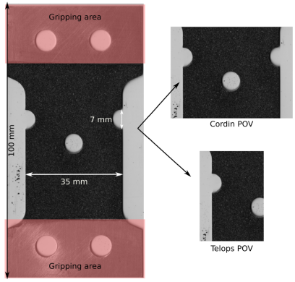 | 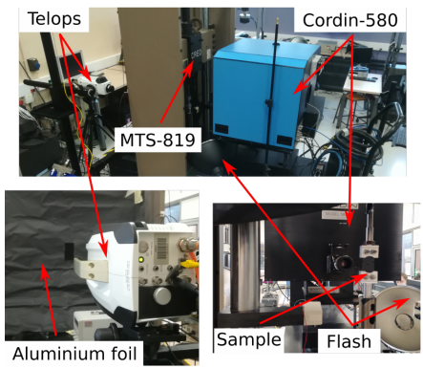
Figure 1: Sample geometry and experimental setup for HS imaging of non-statically determined dynamic test

Results and Discussions
In-plane components of the stress fields have been successfully identified in areas where signal to noise ratio was favourable (see non-transparent areas). The global database resulting from this single experiment ($\underline{\underline{ϵ}},\underline{\underline{ϵ}}\underline{\underline{σ}}$) lives in a 10 dimensional space and allows to capture extremely rich information regarding the rate-dependence of the material. Fig 2. shows stress-strain curves computed by averaging the response of material points undergoing similar mean strain-rate. A yield and flow-stress rate-dependence is captured from 50 to 500 s⁻¹ without any a priori on the model.
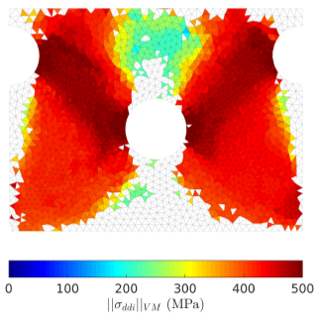 | 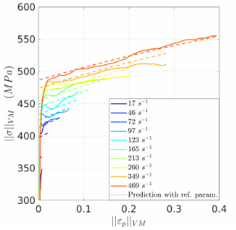
Figure 2: von Mises norm of stress field in plasticity regime and a selection of averaged stress-strain curves resulting from different local strain-rates

Conclusion
The ability of the Data-Driven approach in probing a spectrum of dynamic mechanical response within a single test has been demonstrated. Such technique may be relevant for extreme loading scenarios when local responses tend to fall very far from confirmed validity domain of constitutive equations. In conjunction with machine-learning strategy such Big Database may open the way to a unique strategy for constitutive model formulation.

References
[1] A Leygue et al (2018). Data-based derivation of material response. Comput Methods Appl Math & Eng, 331, 184-196.
[2] R Langlois et al (2022). Non-parametric stress field estimation for history dependent materials. ⟨hal-03520225⟩
[3] A Vinel et al (2021). Metrological assessment of multi‐sensor camera technology for spatially‐resolved ultra‐high‐speed imaging of transient high strain‐rate deformation processes. Strain, 57(4), e12381.

