The concept of improving the fracture toughness of double-phase high entropy alloy produced by high-pulse sintering method U-FAST
D. Górniewicz^{1a}, S. Jóźwiak¹, H. Przygucki² and M. Kopec^{3, 4}
^{1a} Faculty of Advanced Technologies and Chemistry, Military University of Technology, Sylwestra Kaliskiego 2, 00-908 Warsaw, Poland, ²GeniCore Sp. zoo, Wólczyńska 133, 01-919 Warsaw, Poland, ³Institute of Fundamental Technological Research, Polish Academy of Sciences, Pawińskiego 5B, 02-106 Warsaw, Poland, ⁴Department of Mechanical Engineering, Imperial College London, London SW7 2AZ, UK
ªCorrespondence author: dominika.gorniewicz@wat.edu.pl
Abstract. In this paper, double-phase high entropy alloys with the BCC solid solution matrix and the C14 structured intermetallic Laves phase precipitates with the were obtained. The mixture of Co, Cr, Fe, Mn, Ti and CuO powders was sintered at 1000°C for 1 min using innovative high-pulse sintering U-FAST method. Such method allows to obtain complex TiCoCrFeMn and TiCoCrFeMn+5 vol.% CuO double-phase high entropy alloys. The followed annealing process led to the significant improvement of the fracture toughness of 46 % for TiCoCrFeMn alloy and 27 % for TiCoCrFeMn+5vol.%CuO alloy.
Introduction
High-entropy alloys are the materials, that contain one matrix element and several equiatomic alloying elements. These specific alloys comprise multiple principal elements, which considerably increase a possible number of their compositions. High entropy alloys are characterized by excellent specific strength, superior mechanical performance at high temperature and relatively high fracture toughness, which make them a promising candidates for new applications [1-4]. It should be mentioned, that the hexagonal C14 phase in combination with high-strength, high-entropy BCC solid solution matrix extend the possible applications of these materials in the field of nuclear energy [5,6] and high-temperature superconductors [7,8]. However, the C14 phase itself is characterized by a low coefficient of fracture toughness KIc, that not exceed 2 MPa/m^2, which completely eliminates it from potential applications [9]. The strength properties including fracture toughness of high entropy alloys with C14 second phase could be improved by inhibiting the growth of the granular structure by in-situ formed oxide ceramics precipitates. Thus, the main aim of this work was to improve fracture toughness of high entropy alloys in question by a modification of their structure by addition of oxides to their matrix. These oxides could effectively limit the crack propagation. According to the Orowan-Ashby and Mott-Nabarro mechanisms [10], the presence of fine - dispersion particles of different, hard phase in the structure leads to the strengthening of the alloy through the interaction of dislocations with particles. Such phenomenon effectively limit the crack propagation through deflecting or meandering the crack in the grain area, grain boundaries or interfacial boundaries. In addition, the introduced particles increase the elastic stress in the crystal lattice of the grains, which also limits the crack development.
Results
In this work, two different compositions of TiCoCrFeMn and TiCoCrFeMn+5 vol.% CuO were annealed for up to 100 hours at 1000°C and further subjected to Vickers hardness measurements to assess the effect of annealing on fracture toughness (Fig. 1). The fracture toughness was calculated using modified Shetty equation (1) [11].
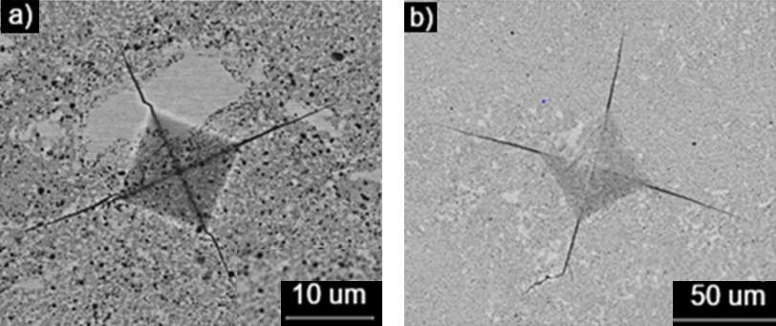
Fig. 1 SEM images of Vickers’s indents observed on alloys annealed for 20h:
a) TiCoCrFeMn indent made at 1,961N load; b) TiCoCrFeMn + 5 vol. % CuO indent made at 19,61N load
$$\text{KIc=0,0937*}{\left[\frac{\text{H}\text{0}\text{(P-P}\text{0}\text{)}}{\text{4l}}\right]}^{\frac{\text{1}}{\text{2}}} (1)$$
where: P is the load; P₀ is a threshold indentation load for cracking; H₀ is the load-independent Vickers microhardness value; l is the average crack length.
The phase structure of these alloys was designed based on the Molecular Orbital Method (Bo Md diagram) in accordance to the literature reports [12,13]. In order to assess the effect of the oxides strengthening on material fracture toughness, CuO was introduced into the powder mixture. The subsequent decomposition of CuO during sintering process led to the formation of TiO₂ which was evenly distributed on the grain boundaries. This phase effectively improved the fracture toughness of materials in question resulting in its subsequent increase of 15 % after long term annealing.
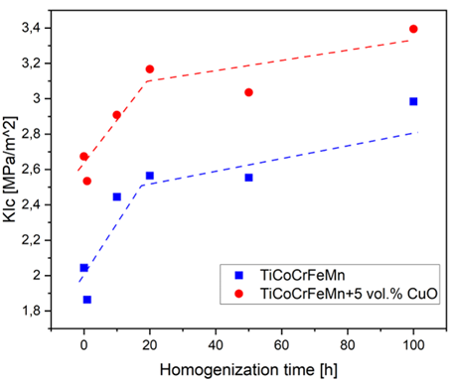
Fig. 2 Fracture toughness / homogenization time dependence for TiCoCrFeMn and TiCoCrFeMn + 5 vol. % CuO alloys.
Conclusions
The annealed materials exhibited about 15% increase of the fracture toughness factor. It was found, that the newly formed TiO₂ phase could effectively prevent the crack propagation of high entropy alloys and thus improve their mechanical properties.

References
[1] M. H. Tsai, R. C. Tsai, T. Chang i W. F. Huang, Intermetallic Phases in High-Entropy Alloys: Statistical Analysis of their Prevalence and Structural Inheritance, Metals, 9 (2019), 1-18
[2] G. Qin, Z. Li, R. Chen, H. Zheng, C. Fan, L. Wang, Y. Su, H. Ding, J. Guo i H. Fu, CocrFemnNi high-entropy alloys reinforced with Laves phase by adding Nb and Ti elements, Journal of Materials Research (2019), 1-10
[3] S. S. Mishra, T. P. Yadav, O. N. Srivastava, N. K. Mukhopadhyay i K. Biswas, Formation and stability of C14 type Laves phase in multi component high-entropy alloys, Journal of Alloys and Compounds, 832 (2020), 1-7.
[4] N. Yurchenko, N. Stepanov i G. Salishchev, Laves-phase formation criterion for high-entropy alloys, Materials Science and technology, 33 (2017), 17-22.
[5] P.J. Barron, A.W. Carruthers, J.W. Fellowes, N.G. Jones, H. Dawson, E.J. Pickering, Towards V-based high-entropy alloys for nuclear fusion applications, Scripta Materialia, 176 (2020), 12-16
[6] E. Pickering, A. Carruther, P. Barron, S. Middleburgh, D. Armstrong, A. Gandy, High-Entropy Alloys for
Advanced Nuclear Applications, Entropy (2021), 1-28
[7] P Koželj, S Vrtnik, A Jelen, S Jazbec, Z Jagličić, S Maiti, M Feuerbacher, W Steurer, and J Dolinšek, Discovery of a superconducting high-entropy alloy, Physical Review Letters, 113 (2014)
[8] Y. Yuan, Y. Wu, X. Liang, H. Wang, X. Liu, Z. Lu, Superconducting Ti15Zr15Nb35Ta35 high-entropy alloy with intermediate electron-phonon coupling, Frontiers in Materials, 5 (2018), 1-6
[9] K. Chen, S. Allen i J. Livingston, Factors affecting the room-temperature mechanical properties of TiCr2-base Laves phase alloys, Materials Science and Engineering, A242 (1998), 162-173
[10] J. Majta, Odkształcenie i własności. Stale mikrostopowe. Wybrane zagadnienia, Kraków: Uczelniane Wydawnictwo Naukowo-Dydaktyczne, AGH (2008)
[11] Y. K. Song, R. A. Varin, Indentation microcracking and toughness of newly discovered ternary intermetallic phases in the Ni-Si-Mg system, Intermetallics, 6, 379-393.
[12] J. Zhang, Mechanical Behavior and Microstructural Evolution in Metastable beta TiMo Based Alloys with TRIP and TWIP Effects, Materials, Université Pierre et Marie Curie - Paris VI, 2014.
[13] R. P. Kolli, A. Devara, A Review of Metastable Beta Titanium Alloys, Metals, 8 (2018), 1-41.

