Ultra-robust Gel hybrids for Epidermal Bio-monitoring

Zibi Wang¹, Ding Wang², Dong Liu¹, Xiang Han¹, Xiaoxu Liu¹, Hamdi Torun², Zhanhu Guo²,
Sidi Duan³, Ximin He³*,Xuehua Zhang⁴*, Ben Bin Xu²*, Fei Chen¹*

¹School of Chemical Engineering and Technology, Xi’an Jiaotong University, No. 28, Xianning West Road, Xi’an, Shaanxi, 710049, PR China,
²Mechanical and Construction Engineering, Faculty of Engineering and Environment, Northumbria University, Newcastle upon Tyne, NE1 8ST, UK
³ Department of Materials Science and Engineering, University of California, Los Angeles (UCLA), Los Angeles, CA 90095, USA
⁴Department of Chemical and Materials Engineering, University of Alberta, Alberta T6G 1H9, Canada
*ben.xu@northumbria.ac.uk

Abstract. Gel based sensor for personal health monitoring and human–machine interaction has attracted enormous interests [1-5]. A seamless and tough interface to integrate incompatible/immiscible soft layers is highly desired for flexible/wearable electronics [6]. Here, we introduce a surfactant mediated interfacial chemistry (SMIC) to achieve seamless and tough interfaces in soft multi-layer structures, with an ultra-high interfacial toughness up to ~1300 J/m2 for the architectural gel hybrid (AGH). The reversible interfacial noncovalent interactions effectively dissipate the energy on interface to sustain an excellent durability with ~2% reduction in interfacial toughness after 1000 tensile cycles. This strategy can be universally applied to the hybrid systems with varied interfaces between interior hydrogel (PAA, PVA, PAAm, gelatin) and exterior hydrophobic soft matter (ionogel, lipogel and elastomer). The AGH based mechano-sensor presents remarkable robustness and stability in a wide range of conditions, i.e. open air, underwater, various solvents and temperatures. Epidermal bio-monitoring, tactile trajectory and facial expression recognition are demonstrated using the AGH sensor in various environments. A rich set of electrophysiological signals are acquired with robust and excellent quality.

Introduction:
Complementary bio-structure with hydrophobic and hydrophilic components exists in nature to fulfill the fundamental functions in various length scales. Amphipathic lipid molecules forming cell membranes are examples at cellular level to ensure the metabolism. Whereas, mammalian skin integrating with the complementary units (oily hydrophobic epidermis and water-contained dermis) to facilitate the desired physiological function is another example at a macro level. Inspired by these bio-structures, hybrid integration of hydrogels with other incompatible/immiscible soft materials, including elastomer, lipid gel (lipogel) and ionic liquid gel (ionogel) is a promising strategy to realize multi-functions in a variety of applications, including responsive materials, soft electronics, biomedical lubrication and flexible actuators. However, the weak interface caused by the intrinsic incompatibility between hydrogel and other soft materials (interfacial toughness < ~1 J/m²), has severely hindered the practical implementation of concept.Effective bonding strategies between hydrogels and other soft materials has been extensively researched. Covalently anchoring long-chain hydrogel networks on solid substrates has secured an interface with a toughness comparable to tendon and bone tissues of human (~800 J/m²). Another method to construct an interfacial interpenetration structure, is to utilize hydrophobic and hydrophilic initiators to form a hydrogel layer on the elastomer surface. These reported strategies mainly focus on creating a hydrogel coating upon hydrophobic soft materials. On the other hand, the reciprocal strategy of controllably generating a hydrophobic layer on the hydrogel surface has not been well explored.

Herein, we propose an interfacial strategy based on surfactant-mediated interfacial chemistry (SMIC) to controllably form a hydrophobic soft layer seamlessly on a hydrogel surface without compromising the homogeneity of either phase. The adsorbed surfactant micelles anchor the hydrophobic silane agents on the hydrophilic hydrogel surface and host the polymerization subsequently. This interfacial strategy achieves a tough interface (up to ~1,300 J/m2 in interfacial toughness), unique solvent resistance, and remarkable durability (~6.9% loss) after 10,000 stretching cycles. This SMIC approach works universally on the interfaces between various exterior soft materials (lipogel, ionogel and elastomer) and interior hydrogels. The exemplified architectural gel hybrid (AGH) can perform precise epidermal bio-monitoring at various environments (open air, different solvents and temperatures).

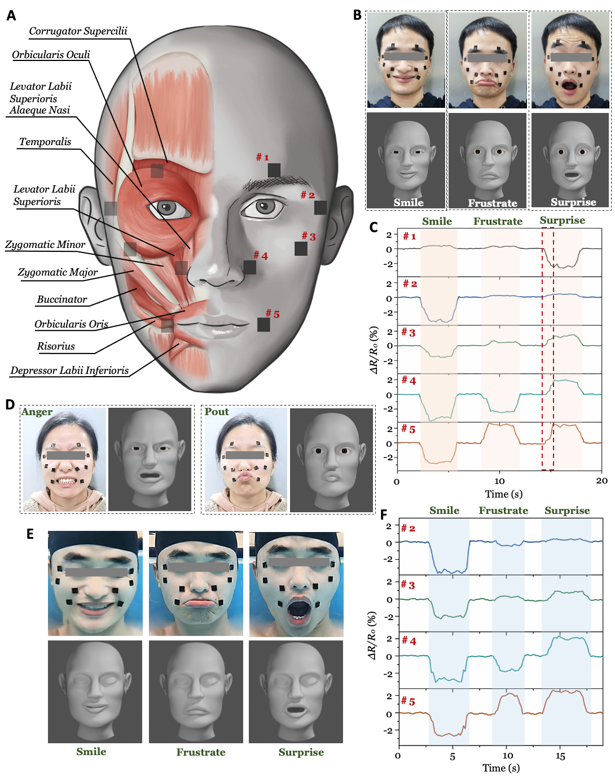
Figure 1. Tactile sensing enabled avatar to reflect dynamic bio-physiological signal acquiring in real time. A) The schematic analysis on facial muscles that determine the expression and deployment of sensors on human face. B) Different expressions on a male volunteer’s face and the corresponding avatars. C) Corresponding sensing signals and detailed expression variations for (B). D) Snapshots of expressions on a female volunteer’s face and corresponding avatars. E) Snapshots of expressions on the male volunteer’s face underwater and the corresponding avatars. F) Outputted signal curves corresponding to these male expressions underwater.

References
[1] L. Pan, G. Yu, D. Zhai, H.R. Lee, W. Zhao, N. Liu, H. Wang, B.C. Tee, Y. Shi, Y. Cui, Z. Bao, Hierarchical nanostructured conducting polymer hydrogel with high electrochemical activity. Proc. Natl. Acad. Sci. U.S.A. 109 (2012), p.9287-92.
[2] H. Wei, Z. Wang, H. Zhang, Y. Huang, Z. Wang, Y. Zhou, B.B. Xu, S. Halila, J. Chen, Ultrastretchable, Highly Transparent, Self-Adhesive, and 3D-Printable Ionic Hydrogels for Multimode Tactical Sensing. Chem. Mater. 33 (2021), p.6731-6742.
[3] Y. Liu, A. Sun, S. Sridhar, Z. Li, Z. Qin, J. Liu, S. Chen, H. Lu, B.Z. Tang, B.B. Xu, Spatially and Reversibly Actuating Soft Gel Structure by Harnessing Multimode Elastic Instabilities. ACS Appl. Mater. Interfaces. 13 (2021), p.36361-9.
[4] Z. Li, Y. Liu, M. Lei, A. Sun, S. Sridhar, Y. Li, X. Liu, H. Lu, Y.Q. Fu, B.B. Xu, Stimuli-responsive gel impregnated surface with switchable lipophilic/oleophobic properties. Soft Mater. 16 (2020), p.1636-41.
[5] Z. Deng, T. Hu, Q. Lei, J. He, P.X. Ma, B. Guo, Stimuli-Responsive Conductive Nanocomposite Hydrogels with High Stretchability, Self-Healing, Adhesiveness, and 3D Printability for Human Motion Sensing. ACS Appl. Mater. Interfaces. 11 (2019), p.6796-6808.
[6] Z. Wu, X. Yang, J. Wu, Conductive Hydrogel- and Organohydrogel-Based Stretchable Sensors. ACS Appl Mater Interfaces. 13 (2021), 2128-2144.

